**ASSIGNMENTS ON DIGITAL MARKETING**

**NAME:** ASWANI K J

**DEPARTMENT:** BE BIOMEDICAL ENGINEERING

**COLLEGE:** 8151 DHANALAKSHMI SRINIVASAN INSTITUTE OF

TECHNOLOGY

**NAANMUDHALVAN COURSE**: DIGITAL MARKETING

**NM ID:** 016EC7C0BCBEB538B6343B48E39171BC

**ASSIGNMENT 1:**

Create a blog or website using Blogspot and WordPress. Customize

The theme design and post new article with 500 words.

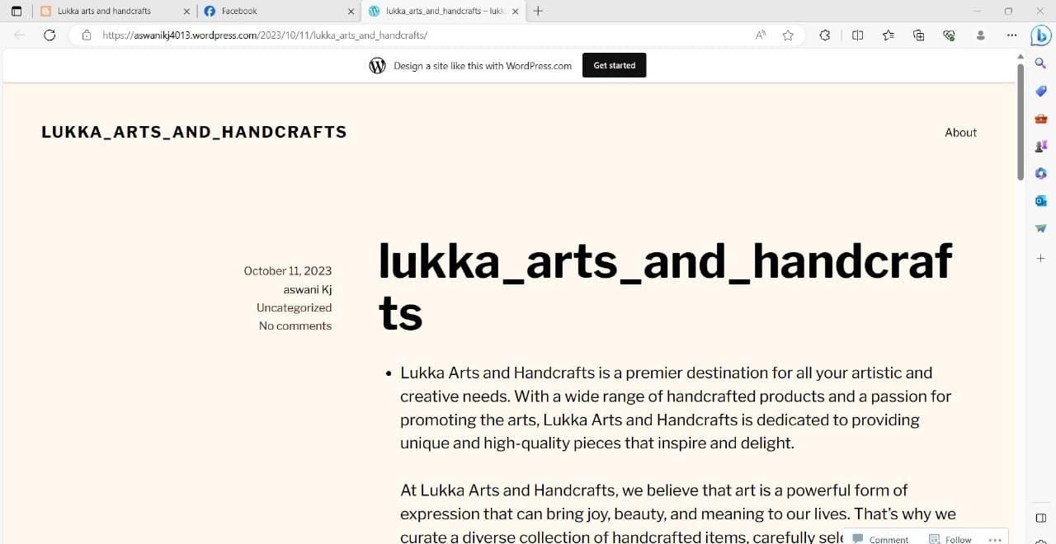 <https://aswanikj4013.wordpress.com/2023/10/11/lukka_arts_and_handcrafts/>

**ASSIGNMENT 2:**

Create a new Facebook business Page and Post one social media poster for your brand.

<https://www.facebook.com/LukkaArtsandHandcrafts>

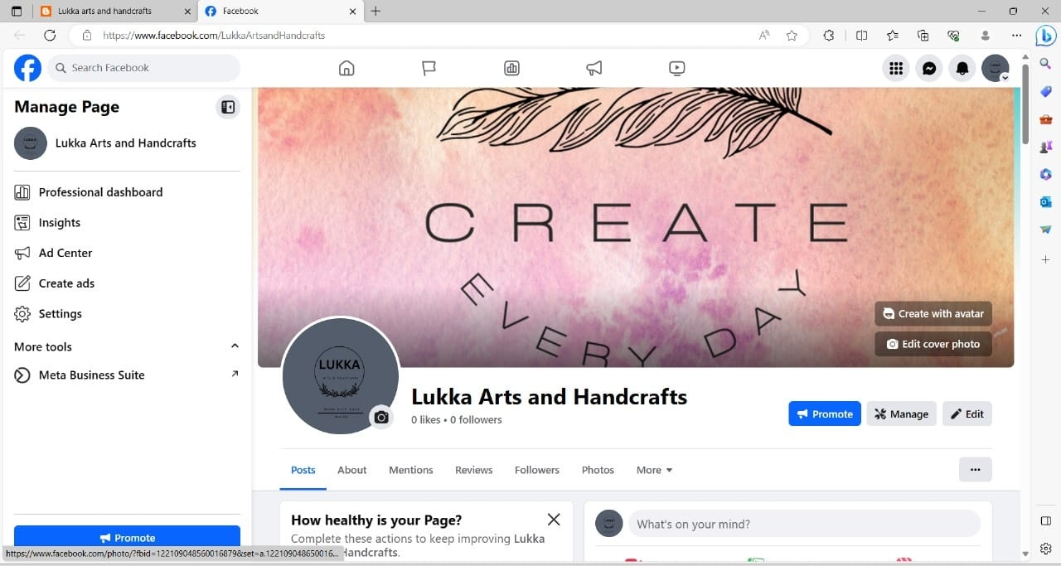

**ASSIGNMENT 3:**

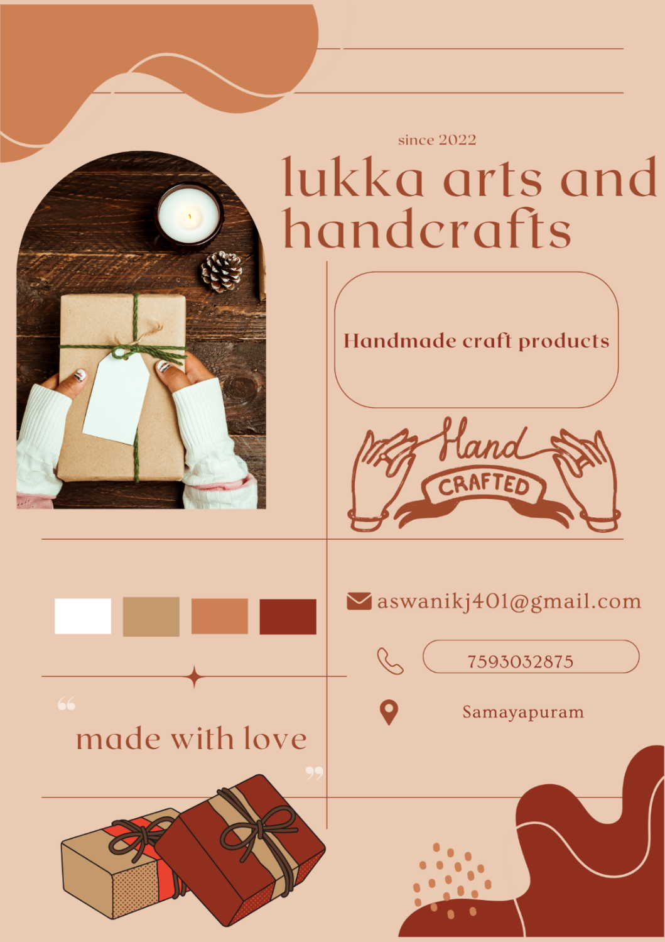Create and design a social media advertisement poster using Canva.

**ASSIGNMENT 4:**

Create email newsletter design using MailChimp or Canva tool.

[https://lukkaartsandhandcrafts.blogspot.com/2023/08/emailnewsletter- lukka-arts-and.html](https://lukkaartsandhandcrafts.blogspot.com/2023/08/emailnewsletter-%20%20%20%20%20%20lukka-arts-and.html)

